John Deere Smart Test Data Analysis

**Executive Summary**

John Deere strives to improve manufacturing processes to continue making high-quality products, as their machines have become more complex with increased digital technologies. To stay ahead, John Deere uses a program called Smart Test. This series of automated tests has a treelike structure that runs on various components of a product throughout the assembly line production process. Smart Test is used to find defects in parts before a machine is fully assembled and shipped to a customer. A test fails when a part is not functioning properly or does not meet standards. John Deere is looking to better utilize insights from the data produced by these tests to identify when, where, and which tests in the production assembly line are failing. The goal of the analysis is to analyze Smart Test data to identify weaknesses in the 6M and 6R Utility Tractor’s test performance. Identifying weaknesses in the assembly line can help pinpoint what processes need improvement to make the highest-quality products effectively and efficiently.

Through the analysis of John Deere Smart Test data, metrics are calculated as an indicator of Smart Test success: First Pass Yield (FPY), Process Performance Index (PPK), and Process Capability Index (CPK). FPY represents the passing percentage for each specific test sequence. PPK measures the variability in overall test performance and has a minimum recommended process capability of 1.33. A value of zero is the most volatile process, while a value of 1.33 to infinity is moving toward a perfectly performing process. CPK also measures the variability in test performance and has a minimum recommended process capability is 1.33 but is aggregated weekly. Identifying portions of the test data that score relatively low on FPY, PPK, and CPK aids the analyst in finding which tests are consistently failing and would require further investigation.

The USB Steckdose test was found to be the worst performing with the lowest FPY. The Kraftsteckdoese-ECE-auf RHK test was discovered to be the most volatile test with the lowest PPK score. Overall, it was found that the 6R model performs worse than the 6M model. It is recommended that the part difference between the 6R and 6M model be analyzed to identify the disparity in performance. An additional suggestion would be to examine the USB sockets to pinpoint the root cause of the issue, delving into aspects such as the supplier's product quality or the possibility of installation errors. Finally, it is recommended to oversee the process involving the installation and manufacturing of the power socket for the kraftsteckdoese test to determine the cause of the variability in result values.

**Methodology**

RStudio was used to clean the test data, remove outliers, and calculate the metrics used to determine test performance. To clean the test data, we first removed columns that had all null values. We then made a pass/fail column that returned a value of 0 representing a fail, or 1 representing a pass. If the result_value of the test was between the minimum or maximum specified limits provided for the test, then a value of 1 is returned; if it is outside the limits, then the test fails and returns a 0. The rows with null values for the minimum, maximum, and result values were removed. This step is meant to remove instances where there were no set limits, or no test results recorded. Next, each path_name was joined to make a unique path to group all the data because each test only must pass one path to be considered a pass. Paths that had less than five occurrences were dropped to include only tests that would be representative of its FPY percentage and score on PPK and CPK. To remove outliers, we split result_value into inner quartiles: the "first" quartile denotes the lower 25%, the "second" quartile signifies the middle 50%, and the "third" quartile represents the upper 75% of the result_value. The values outside of the inner quartiles were then dropped as potential outliers.

PPK is calculated using the grouped “path” and values inside the inner quartiles. Within the PPK formula, the mean and standard deviation of the result value are essential components, represented as µ and σ respectively. Moreover, PPK calculation involves incorporating the upper specification limit, denoted by the maximum value for each test, and the lower specification limit, signified by the minimum value for each test. The formula for PPK is as follows:

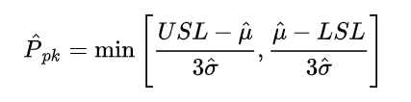

To compute CPK, we first aggregated the "start_date_time" by week to generate a new column indicating the week number. Subsequently, this data was integrated into the same formula utilized for PPK calculation. The distinction lies in the aggregation by the week number, enabling a weekly granular analysis of test variability. This approach offers insights into the fluctuations within tests, allowing for a more detailed examination of volatility trends over time.

In order for John Deere to efficiently engage with data and identify tests with low scores on PPK, CPK, or FPY, we implemented a user-friendly interface using Tableau. Within Tableau, FPY was computed as the percentage of passes (values of 1) in the passfail variable. Subsequently, two Tableau dashboards were created to facilitate granular drilldowns, enabling users to pinpoint the specific Product Line, station ID, Sub. Seq. Name, and Path Name associated with test failures or volatile results.

**Data Structure and Manipulation**

The data we received is a hierarchical tree structure. Tests would start as either a 6M or 6R test and then go through a series of sequences that kick off a specific test. For a test to be a pass, the actual value must be within the minimum and maximum range. 6M and 6R will have the same unique tests run on them. However, the same test will have different minimum and maximum values for a pass. 6M and 6R tractors have separate voltage requirements because of the different components used between the two trim packages.

The raw data we received was 2,016,219 rows and 111 columns of unique tests occurring over an unknown 15-week period. Almost half of the columns were null columns. Figure 1 shows the column names for each of the 56 columns in the raw data with values. Figure 2 displays the column names for the first part of the cleaned data (final_output2). One column that had to be derived was “path.” The column was created by combining “path_name_1” with “path name_5.” Creating the derived column made differentiating the unique tests easier for 6M and 6R. However, “path” is later split back up later in the Tableau Dashboard.

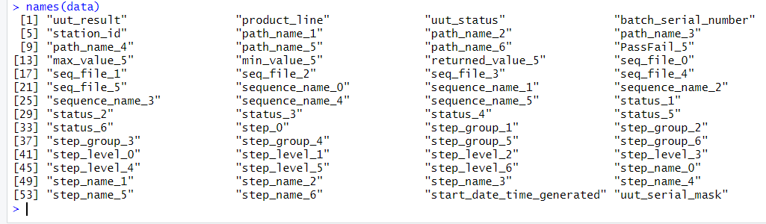

Figure : Total Column Headers from Raw Data



Figure : Column headers John Deere wanted in the cleaned data

A significant number of rows contained null values for the "result_value", "min_value", and "max_value" columns. The rows that had null values had values in “path_name_5” such as “such,” ”as” or “where.” These values in “path_name_5” made us conclude that these rows were most likely a result of lines of code that kicked off the tests and did not collect any values. When we removed these null values, we retained 55,810 rows. Then we removed any values with negative values, resulting in 41 rows being dropped. Some electronic tests may display a reading of 0 when there is an open circuit. We removed these tests because we wanted to focus strictly on tests where other control variables are constant. We felt there were too many reasons to cause an open circuit, from part quality to employee error. If quality engineers wished to include 0 values, removing or commenting out Line 93 in the R code will reintroduce these results. After discarding 1,881 more rows, the final output contained 53,847 rows of data. Figure 3 shows all of the columns in Figure 2 in addition to the added columns needed to calculate the required metrics.

Figure : Column headers for the Final_Output_7.csv file.

**Findings**

Utilizing the user interface built in tableau we were able to uncover multiple different weaknesses in the assembly line process of the 6R and 6M Utility tractor models. Looking high level at the differences between tractor models the 6M model passes tests at a greater rate than the 6R model. We came to this conclusion by looking at the differences between the FPY(First Past Yield) of each model the 6M model has an overall average first pass yield of all tests of 99.33% (Figure 3)whereas the overall average for 6R is 98.70% (Figure 4).

Figure : 6R FPY Over Time

Figure : 6M FPY Over Time

***6R***

Due to the differences in the FPYs of the 6R and 6M models we wanted to dive deeper into the problem areas causing the 6R tractor to perform worse. In our UI we can highlight the top 10 worst performing tests by FPY to see which test sequences are pulling down the average. We were able to find the Steckdose Greenstar (FPY of 96.07), Steckdose USB (FPY of 96.17), and Steckdose Kraftsteckdose ECE auf RHK (FPY of 96.33) are all pulling down the overall FPY for the 6R model (Figure 5).

Figure : 6R Top Worst Performing Tests Based on FPY

**Steckdose Greenstar**

To help the John Deere team trouble shoot the issues with the test sequence Steckdose Greenstar on the 6R model we drilled down on the metrics and found that the PPK is below the preferred range of greater than 1.33 at 0.82. When looking at the distribution of result values we can see that this test is highly unpredictable as values range from 0.25- 7.50 causing a low PPK (Figure 6).

Figure : Steckdose Greenstar Output Value Distribution

**Steckdose USB**

When Looking into the Steckdose USB test sequence there are three different final paths that it takes all having FPYs below the average. The USB Steckdose an AUX, USB-C Ladebuchse, and USB GSix Steckdose are all performing at a below average passing rate as well as having low PPKs (Figure 7).

Figure : Sub Sequence Steckdose USB Final Path Metrics

USB Steckdose an AUX has multiple tests returning values at the lower limit and below causing the low PPK and low FPY(Figure 8).

Figure : USB Steckdose an AUX Result Value Distribution

USB-C Ladebuchse has result values that span far outside of the passing range of 0.25-0.6 the farthest straying values are all the way up to 4.50. With the variability of output values, it makes sense that the PPK would be so low as the test is not controlled and highly varied. This test also fails often near zero causing a low FPY (Figure 9).

Figure : USB-C Ladebuchse Result Value Distribution

The USB GSix Steckdose has the same issue as the output values range all the way up to 6.5 which is far outside of the upper limit of 0.6 causing the low PPK and FPY(Figure 10).

Figure : USB GSix Steckdose Result Value Distribution

**Steckdose Kraftsteckdose ECE auf RHK**

The Steckdose Kraftsteckdose ECE auf RHK test sequence has a low FPY as the test is often failing below the minimum. This test also has an extremely low PPK as the test outcomes very significantly below the passable range often failing between near zero and 1.25 (Figure 11).

Figure : Steckdose Kraftsteckdose ECE auf RHK Result Value Distribution

***6M***

Although the 6M tractor model performs better than the 6R there could still be improvements in the process. There are two test sequences that stand out based on overall FPY that are pulling down the overall performance of the 6M tractor model which are Steckdose USB (FPY of 96.86%) and Steckdose Kraftsteckdose ECE an Staufach (FPY of 97.25%). It is important to call out that the Steckdose USB test is in the top worst performing tests for both 6R and 6M tractor models (Figure 12).

Figure : 6M Top Worst Performing Tests by FPY

**Steckdose USB**

The Subsequence Steckdose USB leads into one final pathname the USB Ladebuchse test which has a FPY of 96.27% and a PPK of 0.85. Looking at this test it often fails below the minimum however the values range significantly over the maximum all the way to 2.50. Leading us to find that this test process is poorly controlled (Figure 13).

Figure : Steckdose USB Result Value Distribution

**Steckdose Kraftsteckdose ECE an Staufach**

The Steckdose Kraftsteckdose ECE an Staufach test sequence also only has one path. This process has the most variation in output values as it ranges below 0.25 and up to 8.75. This test fails most often below the minimum however when it fails higher the values often stray farther from the upper limit than the lower fails stray from the lower limit(Figure 14).

Figure : Steckdose Kraftsteckdose ECE an Staufach Result Value Distribution

The Steckdose Kraftsteckdose ECE an Staufach is also unpredictable week by week having as low as a 92.5% FPY in week 12 and a 100% FPY in week 18 and 19 (Figure 15).

Figure : Steckdose Kraftsteckdose ECE an Staufach Metrics By Week

**User Interface**

The user interface was developed with the purpose of quality control engineers being able to identify a problem at a high level and then being able to identify specific test paths that contribute to the problem. We chose to take this approach to a UI because SMART test failures are an ongoing problem, and this UI can continuously update as time passes.

The first page of the dashboard covers first pass yield (FPY) overall, on the subsequence (.seq) level, weekly level, and the path name 5 level. This allows the user to identify problematic areas at a higher level using FPY to investigate the second page further. To aggregate this data correctly, the pass/fail result was fixed on each individual path name to attain the correct count distinct for pass and fail results. The first page also lists the max/min/result value for each individual test name, which was a specific request of the stakeholders. (Figure 16) Each listing is click-to-filter, so more specific analysis can be conducted.

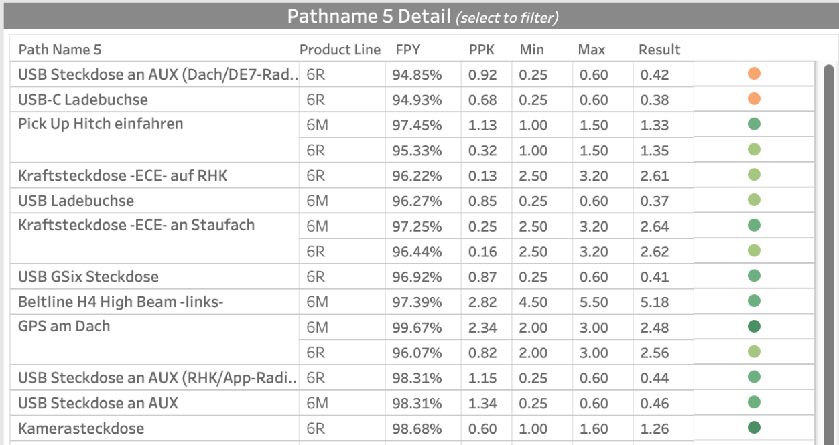

Figure 1: Pathname 5 level detail (request of the stakeholders)

The second page delves into the PPK and CPK values that can be only shown on the test level. The filters applied on page one will carry over to the second page so that the analysis can continue down the progression of granularity. FPY is shown by product line, serial number, station ID, and subsequence name in ascending order and is click-to-filter. (Figure 17) The pathnames are populated below and display the FPY and PPK. The user can then select a test name, which will populate the PPK, result value distribution, and CPK weekly. (Figure 18) This allows the user to gain further insights into what the causation of the FPY, PPK, and CPK are.

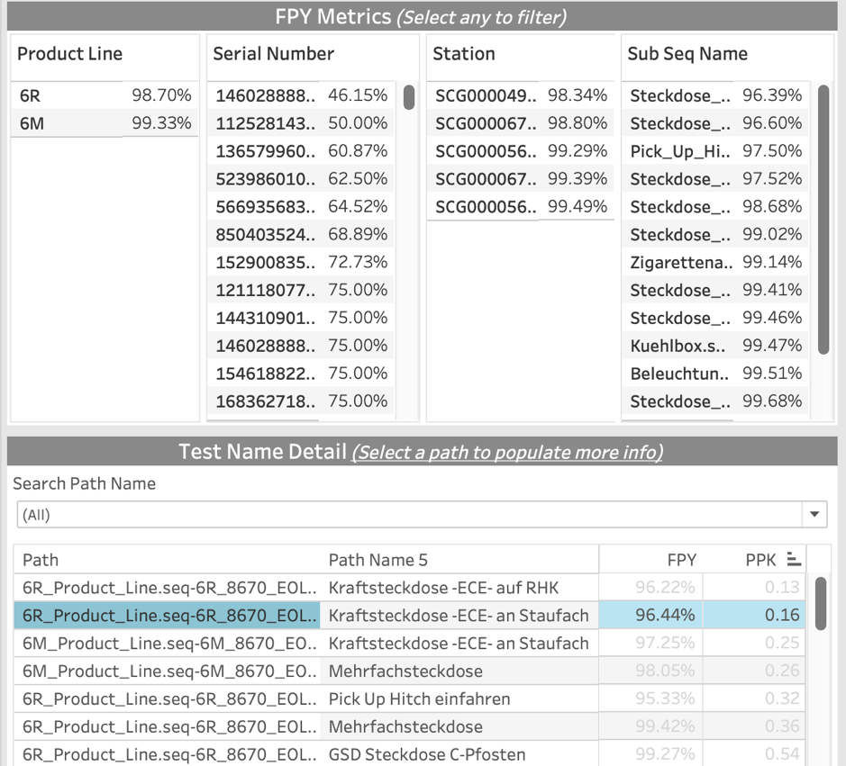

*Figure 17: FPY on various levels and test name detail (FPY, PPK)*

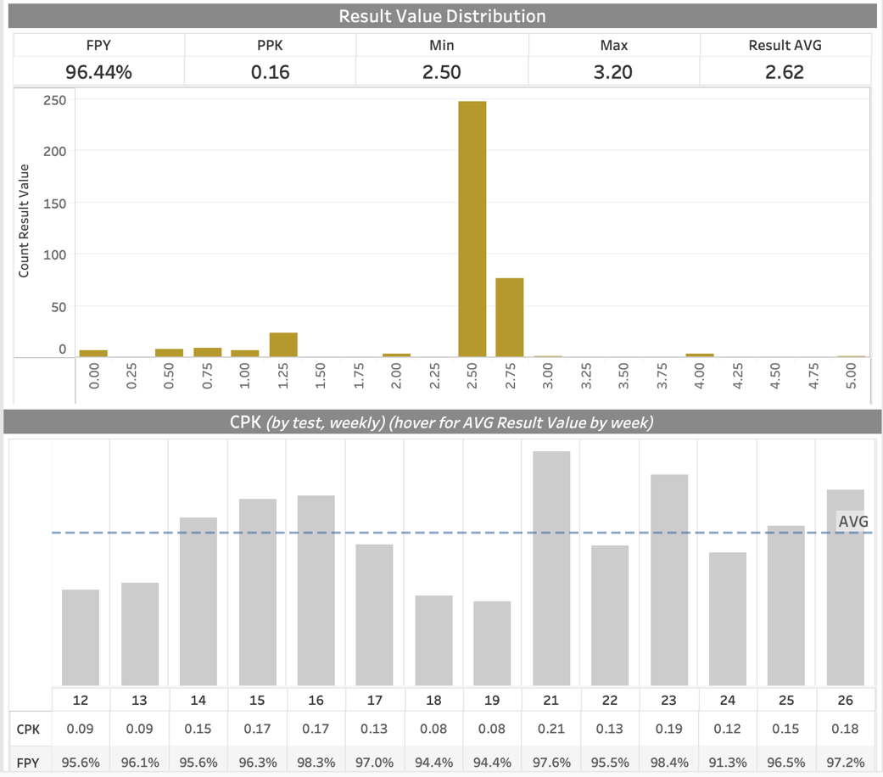

*Figure 18: PPK and CPK detail populated on test level*

Feedback from John Deere we received was building out a view that ranked tests based on how many times they occurred to reflect relevancy and importance of individual tests. We recognize this change's importance as it would allow users to consider test importance when conducting analysis. This UI allowed us to identify current issues and will allow John Deere quality control engineers to identify them in the future. We are confident that this deliverable could serve as a basis on which John Deere may change the way they evaluate the SMART test data to be more efficient.

**Recommendations**

On a high-level our team recommends that John Deere focuses on the overall performance of the 6R tractor model first due to the fact that this model is performing worse overall than the 6M and has greater room to improve overall performance. When analyzing the worst overall tests for each tractor models the one similarity is that they all relate to power outlets (Steckdose in German). We recommend that John Deere analyze the different factors that go into placing and testing power outlets in both the 6R and 6M models.

For example, John Deere could look into the sourcing and manufacturing of the power outlets placed in the tractors to see if this part of the process is where the problem arises from. It could also be due to young inexperienced workers at these stations. Another source of the problem could be the complicated process of wiring electrical outlets. John Deere could create a more streamlined standard work process that helps make electrical wiring simpler and easier for assembly line workers.

Our recommendation is for John Deere to place quality engineers at the assembly stations for Steckdose Greenstar, Steckdose USB, and Steckdose Kraftsteckdose ECE auf RHK for the 6R models and Steckdose USB and Steckdose Kraftsteckdose ECE an Staufach for the 6M models to target and trouble shoot problem sources as there are many factors that could lead to this process’s poor performances.

**Student Takeaways**

Through the process of analyzing John Deere's Smart Test data, we gained practical insights into real-world problem-solving and decision-making. Exploring this extensive data set highlights the inherent challenges of managing vast amounts of information. From cleaning and transforming the data, to structuring it for analysis, we grappled with the multifaceted nature of real-world data management. This hands-on experience equipped us with valuable skills, preparing us for handling complex datasets in our future careers.

Moreover, before this experience with John Deere, our understanding of statistical analysis techniques and performance metrics was limited. We learned applying statistical analysis techniques to assess manufacturing quality provides us with practical insights into optimizing processes and reducing defects. Exploring metrics like First-Pass Yield and Process Performance Indices enables us to identify trends to enhance product reliability and operational efficiency. These skills are crucial for effective quality control, enabling us to drive meaningful improvements in manufacturing processes through data-driven decisions.

Finally, our strategic use of visualization tools, such as Tableau, enhances our ability to communicate complex insights effectively. Many of our team members were able to further develop these skills to drive meaningful change in manufacturing processes. By creating interactive dashboards, we translated our data findings into clear, actionable recommendations for our sponsor. By mastering visualization techniques, we can enhance our ability to derive actionable insights from complex datasets, thereby improving our communication skills and our capacity to influence decision-makers in various professional settings.